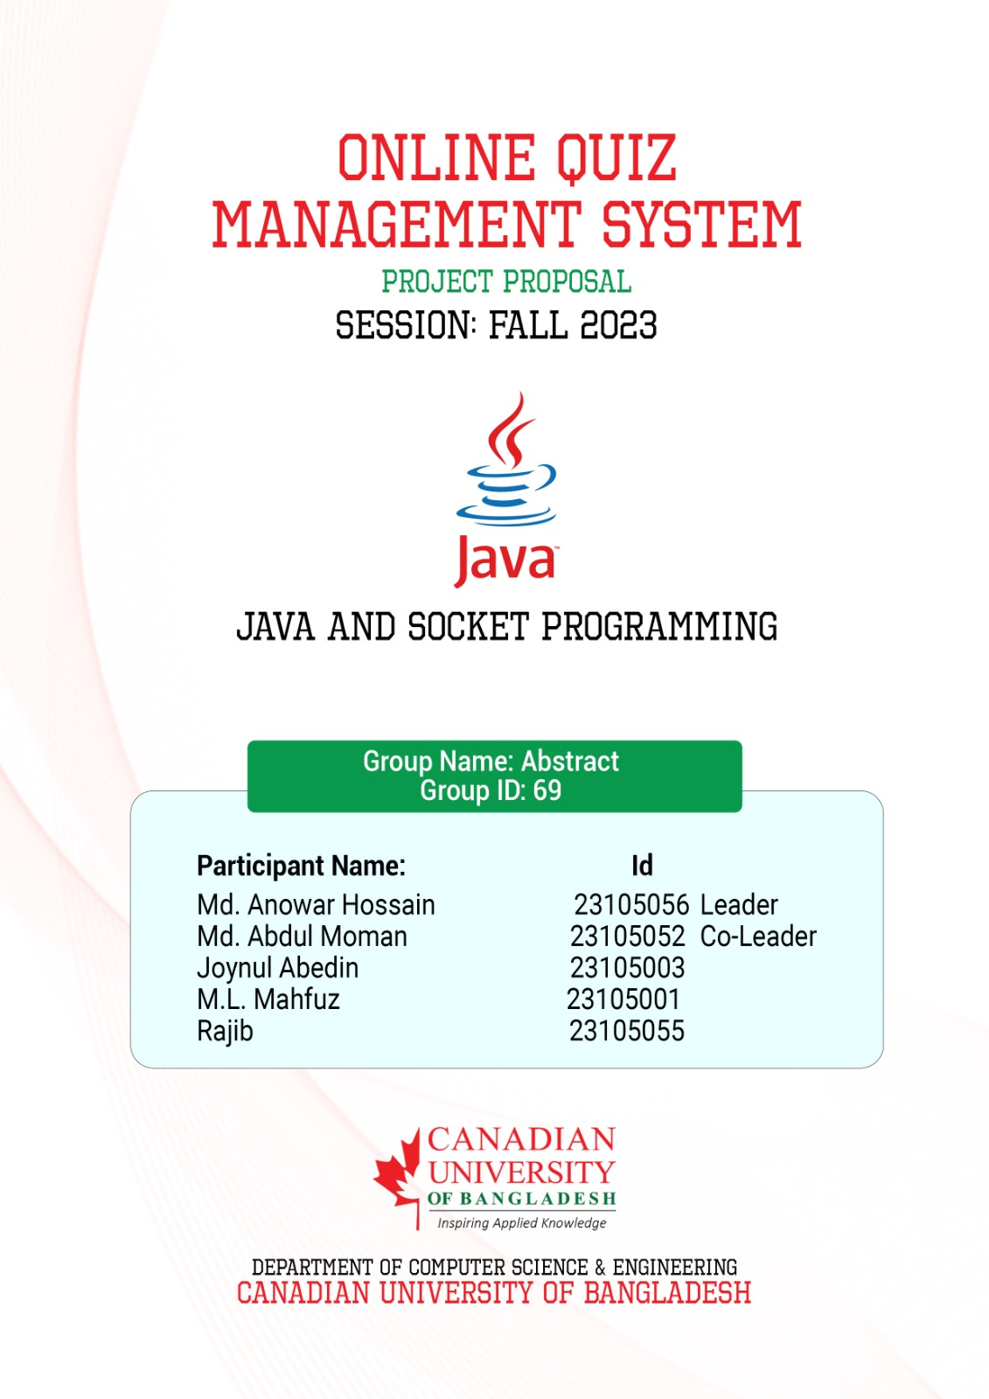

ONLINE QUIZ MANAGEMENT SYSTEM  
<https://github.com/anowaranu/quiz-managment-system.git>

Abstract: The Purpose of Quiz Management System is to automate the existing manual system by the help of computerized equipment and full-fledged computer Software, fulfilling their Requirements, so that their valuable data/information can be stored for a longer period with easy accessing and manipulation of the same. The required software and hardware are easily available and easy to work with. Quiz Management System, as described above, can lead to error free, secure, reliable and fast management system. It can assist the user to concentrate on their other activities rather to concentrate on the record keeping. Basically, the project describes how to manage for good performance and better services to the peoples who are taking part in the quiz. The system will show result after the examination is finished. A teacher has control in the question bank and is supposed to make schedule for the quiz. The system carries out the examination and auto-grading for multiple choice questions which is fed into the system. Administrative control of the whole system is provided.

**KEYWORDS:** QUIZ, OFFLINE

**I. INTRODUCTION:**

The main aim of Quiz **Management System** is to facilitate a user-friendly environment of e-book implementation and reduces the manual effort.

**Users of the system are:**

1. Teachers

2. Students

In past days quiz is conducted manually but in further resolution of the technology we are able to generate the score and pose the queries automatically.

Secure access of confidential data, better design to give effective e-book and flexible. Service based architecture will be highly desirable for future extension. Issues are to reduce the manual pressure and make the project in effective manner.

Teacher is able to make quiz questions and take a contest both.

But students are only able to give a quiz. Their result is visible on the screen after the successful completion of the quiz. Both are able to ask any query from the administrator and give any suggestion to improve the site.

The present project elucidates the following features.

Registration of Teachers and Students

* Making of Quiz
* Taking of Quiz
* Queries from Users
* Contact From administrator.

**II. LITERATURE REVIEW:**

The idea draws motivation from the people who hesitate to visit the police station and personal belief of weak investigation and corruption and limited spreading of crime information. The usage of the internet is increased in every sector, so people find it easier to register a complaint online rather than visiting the police station, it is secure and possible to hide their identity if they want. This application helps to create a bridge between normal people and the police department to share information and evidence. It is helpful to track and monitor the criminals around the state and country and maintain a complete record of criminal information. It helps to search and access a large amount of data in less amount of time and provides a language-independent search over a large amount of data collected from different sources. It provides online assistance and general information and creates awareness among the people. Helps the people to gather general information and valuable advice and crime control methods, along with case investigation status and “SOS‟ capability in which a person can press a button and their location is shared with the nearest police station.

**III. EXISTING SYSTEM:**

The whole process of assigning test and evaluating their scores after the test, was done manually till date. Processing the test paper i.e. checking and distributing respective scores used to take time when the software was not installed.

**DRAWBACKS OF EXISTING SYSTEM**

* The current system is very time consuming.
* It is very difficult to analyze the exam manually.
* To take exam of more candidates more invigilators are required but no need of invigilator in case of on-line exam.
* Results are not precise as calculation and evaluations are done manually.
* The chances of paper leakage are more in current system as compared to proposed system. Result processing takes more time as it is done manually

**IV. PROPOSED SYSTEM:**

The purpose of quiz management simulator is to take offline test in an efficient manner and no time wasting for checking the paper. The main objective of offline test simulator is to efficiently evaluate the candidate thoroughly through a fully automated system that not only saves lot of time but also gives fast results.

For students they give papers according to their convenience and time and there is no need of using extra Thing like paper, pen etc.,

ADVANTAGES OF PROPOSED SYSTEM

The system is very simple in design and to implement. The system requires very low system resources and the system will work in almost all configurations. It has got following features.

• Reduce the damages to the machines.

• Minimum time needed for the various processing.

• Greater efficiency.

• Better service.

• User-friendliness and interaction.

• Minimum time required.

• It saves more time.

• It saves the student's money.

• It saves paper.

• It's more secure.

**V. SYSTEM ARCHITECTURE**

• Login Module

• Register Module

• Exam Module

• Test Module

**MODULE DESCRIPTION**

**Login Module:**

This is the main module in the Quiz Project. In this Module, Firstly, A New User Can Participate for the quiz by Entering their Login Id, Password in the login form. If they are new user then he/she will be firstly registering their name, and create their new User id and password in register module.

**Register Module:**

This is the next module in the Quiz Project. In this Module, A New User can register themselves for participation in the quiz by entering their name, user id and by password and then he /she will be registered.

**Exam Module:**

The Menu Module will contain the subjects we have entered in the project (IP, GK, ENGLISH, COMPUTER BASICS) Subjects and the user will access through login form, and he/she will now access through register form. Then the user will choose a particular subject through radio button and starts a quiz

**Test Module:**

The Test Module will contain the Subject the user will choose then the quiz will be started. The questions will be displayed on the Test Module and the 4 Options are given user will select the appropriate the option and click on next button to the next questions .and user will not able to attempt all questions so he/she will click on get result button to display his/her score. And By Chance the user will skip that question or tick on wrong option so the user clicks on Previous button to move back to previous Question to modify their options.

**I. INPUT DESIGN:**



**II.OUTPUT DESIGN:**



**VI. CONCLUSION:**

In QUIZ management is a web application. The key concept is to minimize the amount of paper and convert all the form of documents to digital form it can observe the information required can be obtained with the easy and accuracy in the computerized system. The user with minimum knowledge about computer can be able to operate the system easily the system also provides a brief result required by the management.

**VII. FUTURE ENHANCEMENT**

Scope of this project is very broad in terms of other manually taking exams. Few of them are: -

* This can be used in educational institutions as well as in corporate world.
* Can be used anywhere any time as it is a web-based application (user location doesn’t matter).
* No restriction that examiner has to be present when the candidate takes the test.

**VIII. PROJECT IMPLEMNTION PLAN**

[**https://docs.google.com/spreadsheets/d/1uNJtKw4_8A-wm9ZqtPqYEeuMBQrkqGICF5Wf-CDzl2o/edit?usp=drive_link**](https://docs.google.com/spreadsheets/d/1uNJtKw4_8A-wm9ZqtPqYEeuMBQrkqGICF5Wf-CDzl2o/edit?usp=drive_link)

**IX. BIBLIOGRAPHY**

**REFERENCES:**

For PHP:

• <https://HYPERLINK> " <https://www.w3schools.com/php/>"

• https://HYPERLINK " <https://www.sitepoint.com/php/>"

• https://HYPERLINK " <https://www.php.net/>"

For MySQL:

• https://HYPERLINK " <https://www.mysql.com/>"

• https://HYPERLINK " <http://www.mysqltutorial.org>"

For XAMPP:

• https://HYPERLINK <http://www.apachefriends.org/download.html>

• Wangkhem, K., & Joshi, K. IOT FOR HEALTHCARE AND ITS CHALLENGES. International Educational Journal of Science and Engineering (IEJSE) –Volume, 1.

• Kaur, J., S., Ganjoo, P., Vaqur, M., & Joshi, K. A Review: Image Fusion using DCT and DWT. International Journal of Scientific & Engineering Research (IJSER)- Volume, 10, 702-707.

• Joshi, K., Kashyap, D., Bisht, B., & Bagwari, A. GPS based Location Tracker: A Review. International Journal of Advanced Research in Computer and Communication Engineering (IJARCCE)- Volume, 8.

• Joshi, K., Joshi, K, N., Diwakar, M. Image Fusion using Cross Bilateral Filter and Wavelet Transform.

Domain. International Journal of Engineering and Advanced Technology (IJEAT)- Volume, 8, 110-115.

• Kumar, R., Singh, G., Joshi, K. Emotion Recognition System using Local Binary Pattern. International.

Journal of Inventive Engineering and Sciences (IJIES)- Volume, 5.

WEBSITES:

• http://www.codeproject.com

• http://www.udemy.com

• http://www.learnpython.org

• http://www.support.microsoft.com

• http://www.codeacademy.com

• http://www.w3schools.com